**Practice Exercise: Create Logical Model, Relational Model, and Generate DDL code:**

**This is a practice exercise for creating logical model, relational model, and generating schema DDL from relational model using Oracle Data Modeler**

**Please create tables with your initial as suffix, e.g. instead of AP_ (replace AP with your initial)**

**Data Dictionary:**

|  |  |  |  |  |
| --- | --- | --- | --- | --- |
| **Table Name** | **AP_EMP** | **EMPLOYEE TABLE** | |  |
| **Column Name** | **Datatype** | **Size** | **Optional/Mandatory** | **Comment** |
| **EMPNO** | **NUMERIC** | **4** | **Mandatory** | **Employee ID Number** |
| **EFNAME** | **VARCHAR** | **30** | **Mandatory** | **Employee Frist Name** |
| **ELNAME** | **VARCHAR** | **30** | **Mandatory** | **Employee Last Name** |
| **JOB** | **VARCHAR** | **30** | **Mandatory** | **Employee Functional Role** |
| **MGR** | **NUMERIC** | **4** | **Optional** | **Employee Manager ID** |
| **HIREDATE** | **DATE** |  | **Mandatory** | **Employee Join Date** |
| **SAL** | **NUMERIC** | **(7,2)** | **Mandatory** | **Employee Monthly Salary in USD** |
| **COMM** | **NUMERIC** | **(7,2)** | **Optional** | **Employee commission** |
|  |  |  |  |  |
| **Table Name** | **AP_DEPT** | **DEPARTMENT TABLE** | |  |
| **Column Name** | **Datatype** | **Size** | **Optional/Mandatory** | **Comment** |
| **DEPTNO** | **NUMERIC** | **2** | **Mandatory** | **Department ID Number** |
| **DNAME** | **VARCHAR** | **30** | **Mandatory** | **Department Name** |
| **LOC** | **VARCHAR** | **30** | **Mandatory** | **Location City of the Department** |
|  |  |  |  |  |
| **Table Name** | **AP_PROJECT** | **ORGANIZATION PROJECTS** | |  |
| **Column Name** | **Datatype** | **Size** | **Optional/Mandatory** | **Comment** |
| **PROJID** | **NUMERIC** | **3** | **Mandatory** | **Project ID Number** |
| **PNAME** | **VARCHAR** | **30** | **Mandatory** | **Name of the Project** |
| **STARTDATE** | **DATE** |  | **Mandatory** | **Start Date of the Project** |
| **ENDDATE** | **DATE** |  | **Mandatory** | **End Date of the Project** |
| **Table Name** | **AP_SALGRADE** | **SALARY GRADE TABLE** | |  |
| **Column Name** | **Datatype** | **Size** | **Optional/Mandatory** | **Comment** |
| **GRADE** | **VARCHAR** | **2** | **Mandatory** | **Salary Grade of Employee** |
| **HISAL** | **NUMERIC** | **(7,2)** | **Mandatory** | **High Salary Value** |
| **LOSAL** | **NUMERIC** | **(7,2)** | **Mandatory** | **Low Salary Value** |

**Highlighted in BLUE is Primary Key of the corresponding table.**

**STEPS FOR CREATING LOGICAL MODEL**

**Create each Entity (table) with all Attributes (columns) with proper datatype, size, optional/mandatory, primary key, and comments for each attributes**

**Create relationship among entities. If there is any Many to Many relationship, create associate (intersect) table in between with at least one attribute. With associate entity in middle, it will have two one to many relationships, with many side towards associate entity.**

**For each relationship, select source key as primary key of the source side table (table which has one side of one-to-many relationship)**

**Convert Logical model to Relational Model**

**Rename Foreign Key column to same column name of primary key of referenced table.**

**Expand Relational Model as necessary so that all details are clearly visible.**

**General DDL script from the relational model and save it as PRACTICE_SCHEMA_DDL.sql on your laptop/desktop.**

**LOGICAL MODEL:**

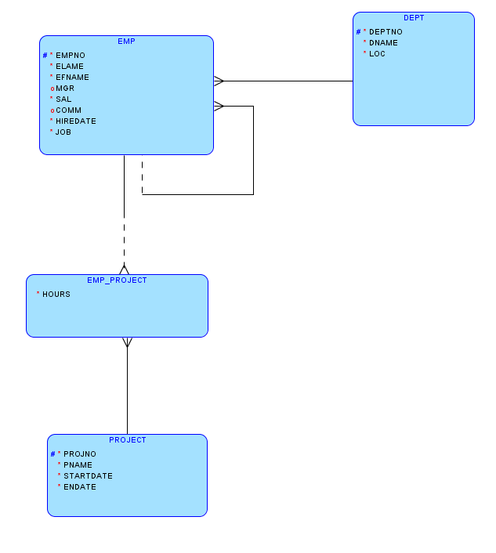

**RELATIONAL MODEL**

